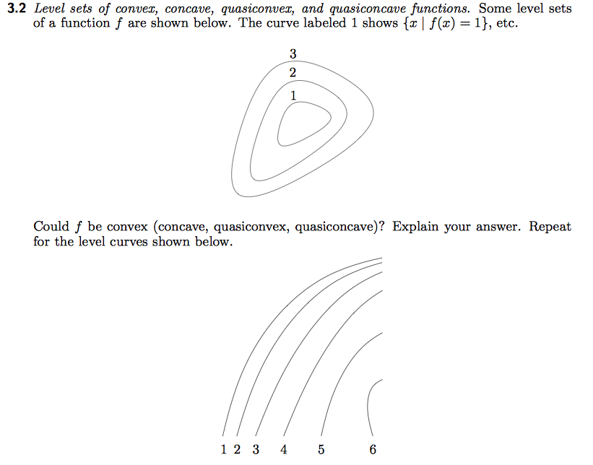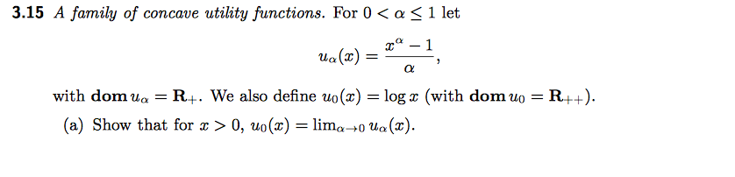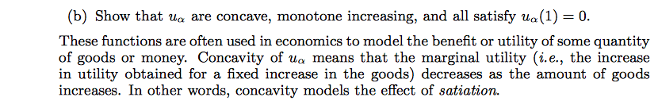

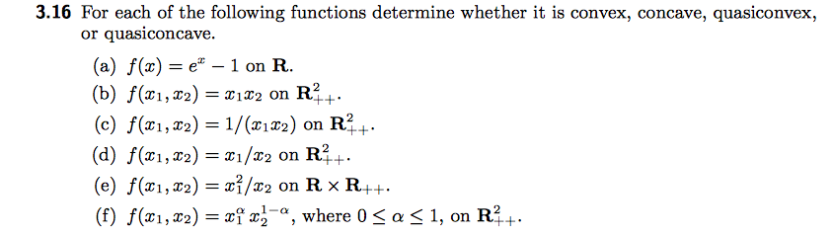



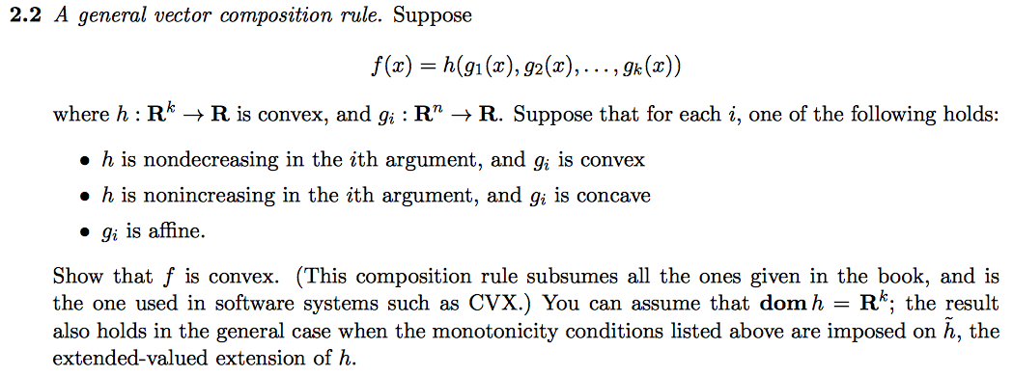

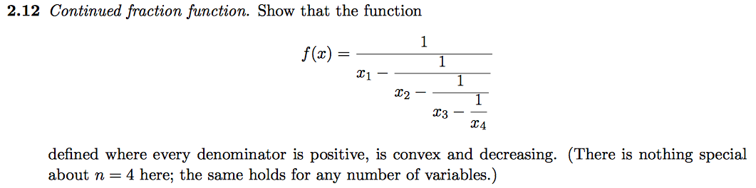

Macintosh HD:Users:Brian:Desktop:Screen Shot 2014-01-16 at 10.29.36 PM.png